CrossWords
Monthly Newsletter of Cross Ev. Lutheran Church
6001 Main St. Rockford, MN 55373 Phone: 763-477-5981
website: www.crosslutheranwels.org email: office@crosslutheranwels.org
Pastor: Rev. Michael Barlow home: 763-477-5292 cell: 763-276-8750
email: pastor@crosslutheranwels.org
March 2017 Volume 17, Issue 3

How to Interpret the Bible

The Bible is God’s Word. The Bible does not merely contain God’s Word. Because the Bible is God’s inspired Word, it is also inerrant, infallible, and true. When we read and study the Bible, we start with that understanding.
As we read and study the Bible, we interpret its message to find its meaning. That is not a difficult task, but there are some simple principles we apply in our study. Those principles apply when we read anything, including the Bible.
The first principle is to understand the historical setting in which the words were written. When we study a portion of Scripture, we consider how it fits into the history of God’s rescue plan for us. We consider other factors: for example, who was writing, where and when he was writing, and why he was writing. We also take into account the conditions of the time, such as religious, political, and cultural conditions, to understand more accurately the one meaning that God’s inspired writers intended.
Another principle we apply in the interpretation of the Bible is that we seek to understand the grammar and words. When communicating, a person uses words. Without knowing the meaning of those words, there is no communication. We also need to understand how those words are put together to make sense. We need to understand the grammar—subject, verb, objects, prepositions. To communicate effectively what God has revealed in his Word, words must be understood according to the one sense that he intended.
The words and phrases the inspired authors used as they wrote the Scriptures have a plain meaning according to their common use, and we interpret them in that way. But sometimes the writers use figurative language. Yes, they wrote history, but they also wrote poetry and used figures of speech like metaphors and illustrations such as the parables of Jesus. In some places we interpret literally and in other places, figuratively. To interpret figurative language as literal distorts the meaning, but so does interpreting literal language as figurative. The words themselves tell us whether they are figurative or literal.
Sometimes we will find places that are difficult to interpret. Then we must simply let the Bible tell us what it means. In other words, we look to other places in Scripture to shed light on the words we don’t understand. Even if our reason still cannot fully grasp what Scripture clearly says, we take God at his word and trust what he says is true.
Most important, the simple message of the Bible is that Jesus is our only Savior. That message is clear without any difficult interpretation.

© 2016 Northwestern Publishing House. All rights reserved. Scripture is taken from THE HOLY BIBLE, NEW INTERNATIONAL VERSION®.

KMSP |  | Channel 9 | Sundays | 6:30 AM

Our Congregation’s Mission Statement
This statement, in a concise and novel way, summarizes our mission and purpose for existing. All other groups and activities within the congregation ought to be carrying this mission out.
Cross Ev. Lutheran Church exists to give glory to our God and Savior by
Regular worship and faithful use of the Means of Grace with
Outreach to the community, nation, and world through our prayers and offerings by
Serving our fellow Christians and community, in turn
Strengthening our faith and promoting Christian fellowship.

Please check out our congregation’s Facebook page and “like” us. Check us out every few days and “like” some of the inspirational and encouraging pictures and share announcements about events with your friends. This is one easy way to share information about our church and God’s Word with others.

NEWS FROM THE CHURCH COUNCIL

Trustees: The council will look into replacing or paiting the white wood on the gables of the church, in addition to the drive through.
The metal doors on the Walnut St ide of the church will be painted this spring or summer.

Upcoming Worship Events
- March 26, Salem Youth Handbell Choir to play here at Cross (Aaron Ernst & Brittany Mutterer play in this group)
- Ash Wednesday – Mar 1, 7pm, Lord’s Supper will be celebrated.
- Midweek Lenten Services: Mar 8,15,22,29, Apr 5 – all 7pm (Pastor exchange)
- Maundy Thursday – Apr 13, 7pm, Lord’s Supper will be celebrated.
- Good Friday – Apr 14; 1pm (The Lord’s Supper will be celebrated only at the 1:00 pm service); 7pm
- Easter Apr 16 Sunrise 7am; Festival Worship – 10am
- Because the pastor will be attending the MN District Spring Pastors’ Conference in Springfield, MO from April 24-26, the will be NO worship on Wednesday, April 26.

Lent/Easter Fellowship meals – starting with March 1, a fellowship meal will be served by a group or organization of the congregation. These are intended to provide an opportunity for fellowship and for convenience. They will go from 5:30-6:30pm on Wednesdays during Lent.
Also on Maundy Thursday the Handbells will serve fellowship meal (5:30pm-6:30pm) and an Easter Breakfast will be served by the choir from 8:00 am to 9:30 am.

Evangelism Some of the upcoming activities the Evangelism Committee are planning include:
- Rockford Expo – Mar 18, 9am – 1pm at the Rockford High School Gym. We will have a booth there. Watch for your chance to sign up to help .
- Easter Postcards will be sent to all homes in Rockford, inviting to our Easter Worship services.
- Easter for Kids – Apr 8, 10am-12pm - an annual event to which our kids and the kids of the community are invited. Bring kids and also consider volunteering to help.

April Meetings: Because of Holy Week services, the April Church Council Meeting will be held on April 20 at 7:00 pm.
The April Congregation Meeting will be held on Sunday, April 30 at 10:15 am.

Youth Under Christ
YUC will be attending an overnite youth lock-in hosted by the youth group of St Peter/Monticello at the Monticello Community Center, starting Friday, March 17 at 9:00 am to 7:00 am, Saturday, March 18

CROSS LIGHTS
Cross LIGHTS will meet in March, on the 7th at 7:30 pm. All the ladies of the congregation are invited to attend.

SUNSHINE COMMITTEE FOR March IS
Edie Wagner

ANNUAL MINNESOTA DISTRICT CHURCH LEADERS’ WORKSHOP -- for Councilmen, Members of Boards and Committees, Called Workers, all men, women and youth interested in carrying out Christ’s Commission to proclaim the Gospel - Saturday, March 4 , 9 AM - 2:30 PM at Trinity Evangelical Lutheran Church in Belle Plaine, MN. Register and Pay online at http://www.welsmn.org Just follow the “Event & Registration” link.

Sunday Morning Bible StudyP Psalms
The Penitential Psalms
Psalms 6,32,38,51,102, 130,143

Sundays, 10:15 am
SUNDAY MORNING BIBLE STUDY – THE PENITENTIAL PSALMS Today we begin a study of the “Penitential Psalms” (Psalms 6,32,38,51, 102, 130 and 143). As we enter the holy season of Lent, these psalms have much to teach us about contrition, repentance and forgiveness. ALL ARE INVITED TO JOIN US IN THIS STUDY.

MEN’S BREAKFAST BIBLE STUDY

On March 25, we will begin a new study, “The Word Endures: Lessons From Luther, Yesterday and Today” as we celebrate the 500th anniversary of the Lutheran Reformation. In this Bible study, we explore key truths from God's Word as echoed by Martin Luther during the Reformation era. By discovering the ways in which Luther taught these principles to the people of his day, your participants will better understand the faith of the famous reformer and grow in their knowledge of doctrines that still root the Christian faith today. Includes eight lessons featuring the following topics:
- Christian Freedom in the Cause of Reform
- Teach the Word to Children
- Appreciate the Role of the Old Testament Law
- Good Works
- Conversion and the Will
- Prayer
- Marriage
- Lord's Supper

NEWS FROM WEST LUTHERAN HIGH SCHOOL
Mrs. Gieseke Announces Retirement
Our beloved math teacher, Sharon Gieseke, has announced her retirement at the end of this school year. Mrs. Gieseke was the first called teacher to West Lutheran in 1979 and has taught Honors Algebra 1, 2, Geometry, Honors Geometry, Trigonometry and PSEO Calculus 1 to a countless number of students. (Well, no doubt Mrs. Gieseke knows the number.)
Beyond making the logic of math understandable, Mrs. Gieseke is also the Junior Class Advisor, Prom Coordinator and Registration Director. Her viewpoint on teaching, "Teaching has always been my passion as a career. Watching students use the abilities God has given them to learn, grow and be stretched is very rewarding. Teaching in a Christian high school allows me the privilege of sharing God's word each day along with math."
Be sure to thank Mrs. Gieseke for all of her service to West Lutheran and to her Lord.
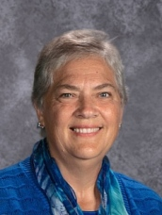

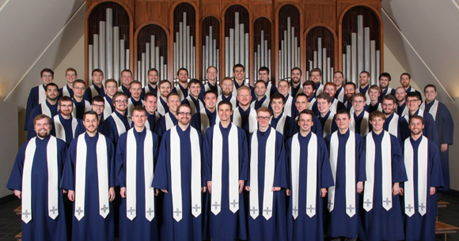
The Wisconsin Lutheran Seminary Chorus is made up of men studying to be pastors at Wisconsin Lutheran Seminary. The chorus will be appearing at West Lutheran High School on March 3rd at 2:00. You are invited to hear the gospel in song.

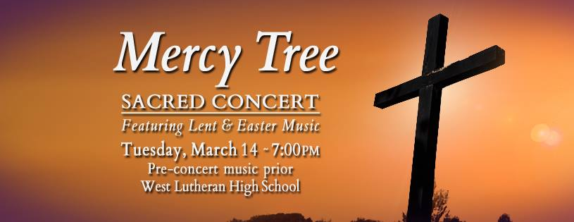

CENTRAL AFRICA MEDICAL MISSION

Lutheran Mobile Clinic (CAMM) Lilongwe, Malawi February, 2017
In the same way, the Spirit helps us in our weakness. We do not know what we ought to pray for, but the Spirit himself intercedes for us with groans that words cannot express. And He who searches our hearts knows the mind of the Spirit, because the Spirit intercedes for the saints in accordance with God’s will.
Romans 8: 26-27

Greetings from the warm heart of Africa,

Failures in communication are frustrating, aren’t they? Just when you think you have selected the exact words you would like to say, the words that actually come out of your mouth are not at all what you had planned to say. Do you struggle to find the right words for a given situation and instead keep silent?

Communication gaps and failures are all too common for me these days, as I am learning to speak Chichewa. Studying a book, using flashcards and practicing conversations with my teacher are indeed helpful, but all too often I find myself lacking the appropriate vocabulary and frustrated that I can’t seem to make myself understood. On more than one occasion I have wished I had my teacher with me so she could fill in the gaps of my broken Chichewa sentences!

Fortunately, I have found that many Malawians are delighted that I am trying to speak Chichewa and are quick to use any English they know when I say, “Pepani. Sindi kumvetsa” (I’m sorry. I don’t understand).

Do you ever wonder if your prayers are hung up in communication gaps with God? Perhaps you have prayed the same prayer year after year but the Lord sends something else. You thought your carefully selected vocabulary was clear, but it seems God misunderstood. Could it be that our thoughts and pleadings are not up to the standard of the Most High? Or maybe you’re not sure what to pray for and you wonder if the Lord would rather you keep silent until you can offer up a well-crafted prayer. If only there was an interpreter to fill in the gaps of our unfocused thoughts and broken sentences!

We can rejoice and take comfort that our prayers are neither lost in translation nor misinterpreted, because our God operates beyond the confines of our narrow thoughts and limited vocabulary. There is no reason to fear that our imperfectly crafted prayers will not be understood by our Father, because Jesus died to win us the privilege of prayer, and the Spirit is actively filling in all of the gaps. There is no communication failure, because the Father sees into our very hearts and knows us better than we know ourselves. He knows what we can bear and what is best for us and “we know that in all things God works for the good of those who love Him, who have been called according to His purpose” (Romans 8:28). Through Jesus, our God is delighted to hear from us in prayer and always sends what we truly need exactly when we truly need it. Always!

Your sister in Christ,
Amanda Artz, Clinic Administrator
Lutheran Mobile Clinic

NEWS FROM WELS & MN DISTRICT
Vacancy Report: Throughout WELS there are currently 103 pastoral vacancies (there were 71 at this time in 2016). Wisconsin Lutheran Seminary will graduate 26 men this May. Thirty men will be available to serve as vicars.

These are vacancies in MN District::
- Beautiful Savior of West Des Moines, IA
- Good Shepherd of Burnsville, MN (calling lead pastor)
- Shepherd of the Hills, Duluth, MN
- Salem of Stillwater, MN (calling associate)
- Salem of Loretto, MN (calling associate)
- Saint Peter of St. Peter, MN (calling associate)
- Crown of Life of West St. Paul (calling associate)
- St. John of New Ulm, MN (calling lead associate)
- Trinity of Belle Plaine (calling lead associate)
- St. John of Lake City, MN
- Redeemer of Maple Grove, MN

One in Christ Offering: Through 1/4/17 4,290 gifts have been received from 2,842 donors (individuals and congregations). These gifts total just over $3.1 million dollars. We praise God for his grace and the generosity it produces in his people. Our synod’s debt was eliminated as of 12/14/16.

Reformation 500: A Confessional Lutheran version of the new Luther film… A Return to Grace: Luther’s Life and Legacy will be rolled out during the next few months. The goal is to encourage WELS and ELS congregations to use a theatre showing as an outreach opportunity in their communities. Mount Olive in Appleton, WI, Holy Word in Austin, TX and Peace Lutheran (ELS) in North Mankato are pilot congregations for the roll out. They will host a showing of the film in February.

100th anniversary of the Wisconsin/Minnesota/Michigan Merger:
2017 marks the 100th Anniversary of the merger of the Wisconsin, Minnesota and Michigan Synods. Our district is making plans to celebrate this event as the 100th anniversary of our synod / 150th anniversary of our synod/district.

Upcoming Events
Our spring pastoral conference will be held from April 24-26 in Sprinfield, MO. .

Our Synod convention will be held July 31-August 3, 2017 at Luther Preparatory School in Watertown, WI.

Wisconsin Lutheran Seminary Symposium – October 1-3, 2017. Four essays on the Lutheran Reformation will be presented. Symposium festivities will include a Sunday evening Luther Hymn Festival and a Monday evening banquet.

500th anniversary of the Lutheran Reformation is in the planning stages. There will be a gathering at Martin Luther College on October 28, 2017 and one at St. Croix Lutheran High School on the same date.

t

Serving The Lord In March 2017

DATE | USHERS | GREETERS | COUNTERS | A/V TECH
Wednesday  (Ash Wed)  Mar 1  7:00 pm | Pete Heibel | Ron Larson | Dennis & Janet Beise | Lori Petersen
Sunday  Mar 5 | Chuck Landeck  Rudy Wassermann  Bob Randall  Lynn Marschel | Volunteers | Marty & Cindy Bogart | Elly Landeck
Wednesday  Mar 8  (Midweek 2)  7:00 pm | Ken Beise  Troy Beise | Pete & Avie Heibel | Chuck Landeck | Phil Ernst
Sunday  Mar 12 | Greg Taylor  John Schuster  Kevin Koehler  Dan Mutterer | Ken & Sharon Koehler | Bart &Janice Skafte | Aaron Ernst
Wednesday  Mar 15  (Midweek 3)  7:00 pm | Joel Schulze | Merrill & Barb Baker | Lori Peterson | Lori Peterson
Sunday  Mar 19  9:00 am | Marty Bogart  Tim Mutterer  Brent Vergin | Kevin & Jackie Koehler | Rudy Wassermann & Dan Mutterer | Jennifer Bogart
Wednesday  Mar 22  (Midweek 4)  7:00 pm | Pete Heibel | Lori Petersen | Eugene & Arlene Mutterer | Phil Ernst
Sunday  Mar 26 | Tom Ernst  Mike Ohm  Phil Ernst  Mark Kettenacker | Myron & Ann Ohm | Dan & Emma Hanson | Blake Koehler

March 2017

Sun | Mon | Tue | Wed | Thu | Fri | Sat
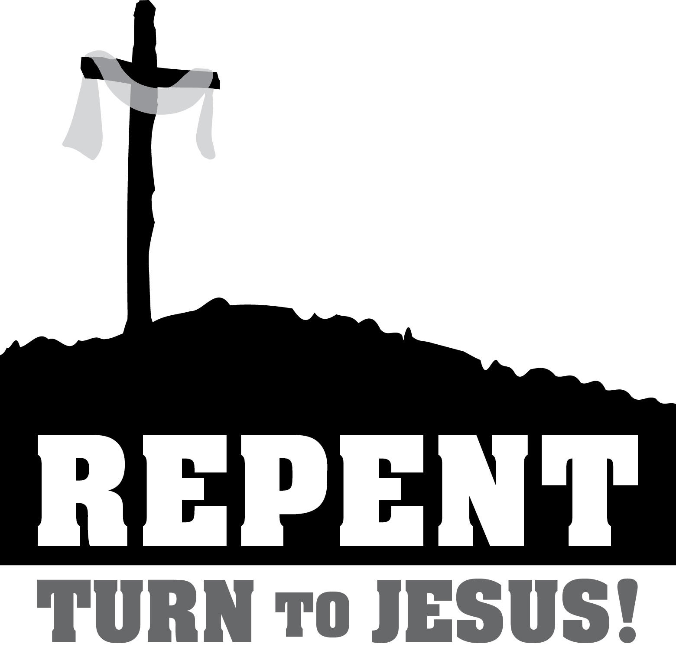 |  |  | 1 (Ash Wednesday)  5:30pmLent Supper  7:00pm Worship (Lord’s Supper)  8:00pm Choir | 2 | 3 | 4  9:00am Church Leaders Workshop in Belle Plaine
5  9:00amWorship (Lord’s Supper)  10:15am Sunday School & Bible Study | 6  9:30am Monday Morning Bible Study  6:00pm Catechism  7:00pm Banner Committee | 7  6:45pm Handbells  7:30pm Cross LIGHTS | 8  10:00am Parkview Devotion  5:30pmLent Supper 7:00pm Worship 8:00pm Choir | 9  6:15pm Elders’& Trustees Meetings  7:00pm Church Council | 10 | 11
12 Daylight Savings Time Begins)  9:00amWorship  10:15am Sunday School & Bible Study  1:00pm | 13  9:30am Monday Morning Bible Study  6:00pm Catechism  7:00pm Banner Committee  7:30pm Evangelism | 14  11:00am Pastor’s Study Club  7:00pm Handbells  7:00pm West Luth HS Sacred Concert  8:00pm Sunday School Teachers | 15  5:30pmLent Supper 7:00pm Worship 8:00pm Choir | 16 | 17  9:00pm Youth Lock-In @ Monticello | 18  9:00am – 1:00pm Rockford Expo
19  9:00amWorship (Lord’s Supper)  10:15am Sunday School, YUC & Bible Study | 20  9:30am Monday Morning Bible Study  6:00pm Catechism  7:00pm Banner Committee | 21  7:00pm Handbells | 22  5:30pmLent Supper 7:00pm Worship 8:00pm Choir | 23 | 24 | 25  9:00am Men’s Breakfast Bible Study
26  9:00amWorship  10:15am Sunday School & Bible Study | 27  9:30am Monday Morning Bible Study  6:00pm Catechism  7:00pm Banner Committee | 28  7:00pm Handbells | 29  5:30pmLent Supper 7:00pm Worship 8:00pm Choir | 30 | 31

2017 Lent & Easter Schedule
Repent: Turn to Jesus . . .

DATE | Preacher | Text & Theme;  Scripture Lessons | Special Music & Hymns | Fellowship Meal
Ash Wednesday  March 1, 7:00pm | M Barlow | Lk 18:9-14  Not to Yourself.  Nu 21:4-9; 2 Co 7:8-13 Lk 18:9-14 | Choir  98-303-304-272 | Church Council  (Soup Supper)  5:30-6:30pm
Midweek 2  Wednesday  March 8, 7:00pm | S. Smith | Mk 14:32-38  -When You Face Temptation  Passion History, Pt 1 | Sunday School  121-472-455-108 | Senior Fellowship  (Wienies & Beans)
Midweek 3  Wednesday  March 15, 7:00pm | P Schuler | Lk 23:32-34  - He Longs to Forgive You.  Passion History, Pt 2 | Handbells  126 – 117:1,4,6,7 – 387 - 118 | YUC  (Egg Rolls)
Midweek 4  Wednesday  March 22, 7:00 pm | M Barlow | Lk 7:44-50  -He changes Your Life.  Passion History, Pt 3 | Choir  306 – 349 – 129 - 385 | Cross LIGHTS  (Sloppy Joes)
Midweek 5  Wednesday, March 29, 7:00 pm | J Grabitske | Lk 23:35-43 -  - He Holds the Keys to Heaven  Passion History, Pt 4 | Ladies Choir  124 – 120 – 112 - 111 | Sunday School
Midweek 6  Wednesday,  April 5, 7:00pm | P Margraff | Matthew 27:1-5 - Do Not Turn Away  Passion History, Pt 5 | Handbells  102 – 302 – 109 - 116 | Church Council  (Tacos)  5:30-6:30pm
Maundy Thursday  April 13, 7:00pm | M Barlow | 1 Co 11:23-28  - and receive special assurance of Your Forgiveness  Jer 31:31-34; 1 Co 11:23-28; Jn 13:1-15,34 | Choir  136 – 313 – 311 – 312:8 | Handbells  530-6:30pm
Good Friday  April 14, 1:00pm & 7:00pm | M Barlow | John 19:17-30  - He Alone Finished Your Salvation | Service at the Cross | NA
Easter Sunrise  April16, 7:00am | M Barlow | Lk 24:1-8  - for Resurrection and Life | Choir  157 - 161 – 163 - 152 | Easter Breakfast  8:00-9:30am
Easter Festival  April 16, 10:00am | M Barlow | Lk 24:1-8  - for Resurrection and Life | Choir  143 – 145 – 150 - 162

